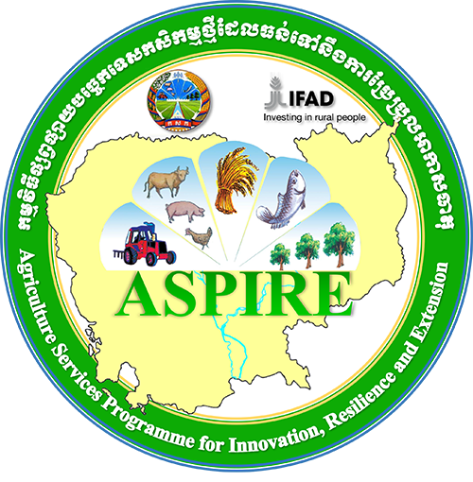
National Committee for Sub-national Democratic Development Secretariat (NCDD-S)
ASPIRE Component 4
JOB ADVERTISEMENT

The Royal Government of Cambodia has received ﬁnancing in the form of a loan (USD26.1 million) from the International Fund for Agricultural Development, a grant (USD15 million) from the Adaptation for Smallholder Agriculture Programme Trust Fund, and Government funding (USD11.4 million) from the Ministry of Economy and Finance to implement the Agriculture Services Programme for Innovation, Resilience and Extension (ASPIRE) for the Ministry of Agriculture, Forestry and Fisheries (MAFF). The total programme costs are forecast at approximately USD 52.5 million (excluding contributions from USAID and beneﬁciaries) and will cover a seven-year implementation period across 11 provinces: Kampong Chhnang, Pursat, Battambong, Preah Vihear, Kratie, Stengtreng, Preveng, Svayrieng, Kandal, Takeo and Kampot province.
The goal of ASPIRE is to reduce poverty and increase the resilience of poor and vulnerable smallholder farmers in the Kingdom of Cambodia. And the main development objective is that enhanced models of agricultural services are formulated and put into practice by 2021 in order to assist a diversity of smallholder farmers to contribute to broad-based economic growth through proﬁtable and resilient farm businesses.
The National Committee for Democratic Development at Sub-National Level (NCDD-S) is the Implementing Agency for Component 4 of ASPIRE, Climate Resilient Infra- structure. Component 4 contributes to Outcome 3 of ASPIRE,” At least 120,000 smallholders have improved and resilient farm businesses as a result of integrated, demand led extension services and investments in climate resilient infrastructure.” It is planned that there will be around 70,000 direct beneﬁciaries of investments in climate resilient infrastructure by sub-national administrations at District and Commune levels. Through synergies with NP-SNDD and with other interventions of NCDD-S supporting climate change adaptation at sub-national level, ASPIRE will contribute to mainstreaming Climate Change Resilience into Sub-National planning and ﬁnance systems. It is planned that up to 32 Districts and 180 Communes will receive ﬁnancing in the form of Performance Based Climate Resilience Grants. In addition, NCDD-S will facilitate smooth cooperation between the sub-national administrations and the agriculture activities of ASPIRE.
The ASPIRE Component 4 uses Performance Based Climate Resilience Grants (PBCRG) to support for building small scale climate resilience infrastructure at sub-national level for supporting local agriculture development and building capacity of local community on climate change adaptation in 24 target districts in 8 target province provinces from 2017.
The ASPIRE Component 4 at NCDD Secretariat is seeking two qualified national short term consultants 1) a National Knowledge Management Specialist to develop the poster and writing best practice and case study of programme implementation in 2018 and 2) a District Climate and Landscape Analysis Specialist to review and improve the district climate change adaptation strategy with (GIS) and develop a Specific Investment Climate Resilience Grant (SICRG) project proposal for one target district.

Position Title | No of Position | Duration | Location
National Knowledge Management Specialist | 1 | 21 Dec 2018 -09 Jan 2019 | ASPIRE/NCDD-S, Phnom Penh and Field work in 2 provinces
National Climate and Landscape Analysis Specialist | 1 | 21 Dec 2018- 08 Feb 2019 | ASPIRE/NCDD-S, Phnom Penh and Field work in a provinces
1-The national Knowledge Management Specialist is expected to have the following skills and qualifications:
- Graduate degree (master’s preferred) in education, environmental science, climate Change or another relevant discipline;
- At least three years professional experience post-graduation;
- Strong background in education, knowledge management, writing case study, writing best practice and poster development or similar tasks;
- Strong understanding of the impacts of climate change on Cambodian rural communities, and suitable strategies for climate change adaptation;
- Experience of working with Government officials (substantial experience working with sub-national governments preferred);
- Strong numeracy;
- Experience case study and poster development of Climate Change Adaptation Project preferred;
- Experience in climate change adaptation project;
- Native Khmer speaker, strong English language skills preferred.
2-The national district climate and Landscape Analysis Specialist is expected to have the following skills and qualifications:
- Graduate degree (master’s preferred) in social science, environmental science, climate change, GIS or another relevant discipline;
- At least three years professional experience post-graduation;
- Strong background in climate change analysis, climate change adaptation strategic development with GIS including experience of developing proposal on Specific Investment Climate Resilience Grant (SICRG) or similar tasks;
- Strong understanding of the impacts of climate change on Cambodian rural communities, and suitable strategies for climate change adaptation;
- Experience of working with Government officials (substantial experience working with sub-national governments preferred);
- Strong numeracy;
- Experience in develop proposal of Climate Change Adaptation Project preferred;
- Experience in SICRG project development is preferred;
- Native Khmer speaker, strong English language skills preferred.
Detail of Terms of Reference (ToRs) for each position are available at http://ncdd.gov.kh/citizens/job-advertisement-aspire-component-4/
Applications should be submitted by 17 December, 2018 via Ms. Sak Channita
Email: channitasak@ncdd.gov.kh or chumsocheatt@gmail.com or to NCDD Secretariat, Building T, Ministry of Interior
Only shortlisted candidates will be contacted for interview

